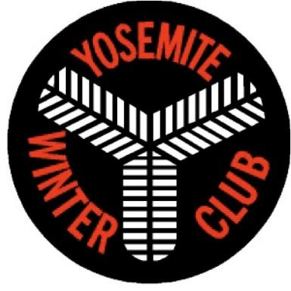
SKI, SNOWBOARD, ICE SKATE/HOCKEY CAMP
2018 SCHOLARSHIP APPLICATION
for KIDS & TEENS
This application is due by Sunday, April 8, 2018
Send completed application to christy_hurlburt@yahoo.com
Scholarship winners will be selected by April 22, 2018.

PLEASE NOTE: YOU MUST BE A YOSEMITE WINTER CLUB MEMBER IN ORDER TO BE ELIGIBLE TO APPLY FOR A YWC CAMP SCHOLARSHIP.

DATE:
NAME:
AGE:
PARENT NAME:
TELEPHONE:
POSTAL MAILING ADDRESS:
PARENT E-MAIL ADDRESS:

Before sending the application, you must search for the camp you would like to attend and find the dates and cost. You can also apply for an Ostrander Ski Hut Fee Scholarship for 2018-2019, which would pay for up to two nights at the Hut for a date that you are able to reserve. YWC selects scholarship winners and funds partial or full scholarships, but not transportation costs.

- Are you a member of the Yosemite Winter Club?
- Are you currently on the Yosemite Ski, Snowboard, Freestyle or Ice Skate Team or on any other winter sport team? For how many years have you been participating in winter sports?
- Please describe what you like most about your winter sport(s) and how it benefits you.
- Have you and/or your family volunteered to help at races, practices, school ski days, or any Yosemite Winter Club fundraising events or will you and/or your family commit to do so this or next winter season? Please describe.
- Describe any Yosemite Winter Club scholarships you have received in the past with the year and amount. Describe any ski or skate camps you have attended and how attending helped you to improve.
- Describe the camp you would like to attend this summer, the location, the cost, and the amount you are applying for. What improvements to your technique do you hope to see?
- Do you plan to join a Yosemite Ski, Snowboard, Freestyle or Ice Skate team for NEXT winter season? Please describe.
- Is there anything else you would like us to know?

